Lab Objective

Encrypting a Volume with BitLocker

**Lab Procedures**

# Encrypting Files with EFS

**1.** Log in to Server02 as the **Contoso\Administrator** user account. The Server Manager console opens.

**2.** On Server02, on Server Manager, click Manage and click Add Roles and Features. The Add Roles and Feature Wizard opens.

**3.** On the Before you begin page, click Next.

**4.** Select Role-based or feature-based installation and then click Next.

**5.** On the Select destination server page, click Next.

**6.** On the Select server roles page, click Next.

**7.** On the Select features page, select BitLocker Drive Encryption.

**8.** When the Add Roles and Features Wizard dialog box displays, click Add Features.

**9.** On the Select Features page, click Next.

**10.** On the Confirm installation selections page, click Install.

**11.** When BitLocker is installed, click Close.

**12.** Reboot the Server02.

**13.** Log in to Server02 as the **Contoso\Administrator**. The Server Manager console opens.

**14.** Using Server Manager, open the Tools menu and click Computer Management. The Computer Management console opens.

**15.** Expand the Storage node and click Disk Management.

**16.** Right-click the C drive and click Shrink Volume.

**17.** In the *Enter the amount of space to shrink in MB* text box, type **3000** and click Shrink.

**18.** Under Disk 0, right-click the unused space and click New Simple Volume.

**19.** When the Welcome to the New Simple Volume Wizard starts, click Next.

**20.** On the Specify Volume Size page, click Next.

**21.** On the Assign Drive Letter or Path page, click Next.

**22.** On the Format Partition page, click Next.

**23.** When the wizard is complete, click Finish.

**24.** Close Computer Management.

**25.** Click the Start button, and then click the Control Panel.

**26.** Click BitLocker Drive Encryption. The BitLocker Drive Encryption window opens as shown in Figure 6-10.

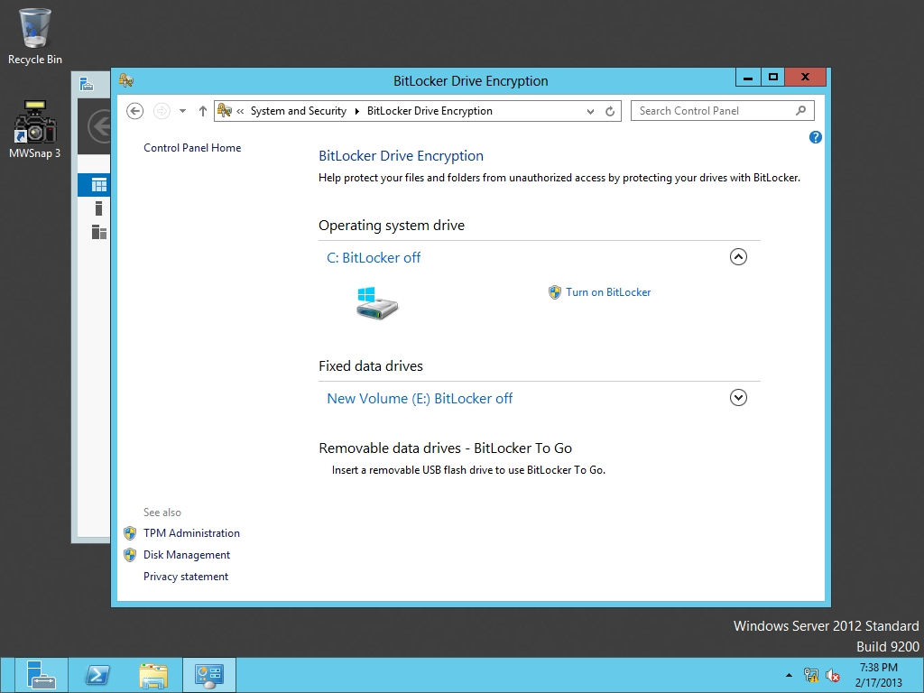

Figure 6-10

Opening the BitLocker settings

**27.** Click the down arrow next to the E drive. Then click Turn on BitLocker. A BitLocker Drive Encryption (E:) window opens.

**28.** On the *Choose how you want to unlock this drive* page, click to select the *Use a password to unlock the drive*. Type a password of **Password01** in the *Enter your password and Reenter your password* text boxes, and then click Next.

**29.** On the *How do you want to back up your recovery key?* page, click Save to a file option.

**30.** When the *Save BitLocker recovery key as dialog box* opens, type **\\rwdc01\Software\** before BitLocker Recovery Key <GUID>.txt and click Save. Click Next.

**31.** On the BitLocker Drive Encryption (E:) page, select Encrypt entire drive radio button, and click Next.

**32.** On the *Are you ready to encrypt this drive?* page, click Start encrypting.

**33.** When the drive is encrypted, take a screen shot of the BitLocker window by pressing Alt+Prt Scr and then paste it into your Lab06_worksheet file in the page provided by pressing Ctrl+V

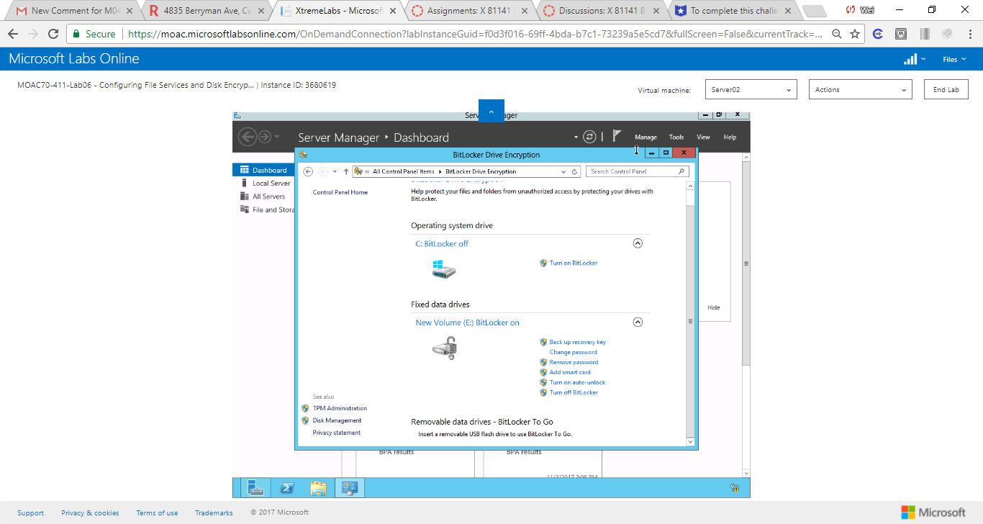

Figure 1 On the Are you ready to encrypt this drive? page, click Start encrypting

**34.** Close the BitLocker Drive Encryption window.

**Lab Summary**

In this exercise, I created a new volume and then use BitLocker to encrypt the entire volume. I control BitLocker from Control Panel. How does EFS and BitLocker differ? EFS is used to encyrpt a single file or folder while BitLocker is used to encyrpt an entire volume.